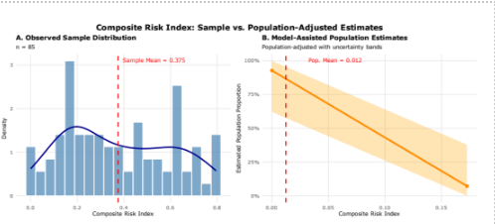
Figure 2 Model-Assisted Estimates of Composite Risk Index. Distribution comparison between observed sample data and population-adjusted estimates. The left panel shows the empirical distribution of risk scores in the RDS sample, while the rights panel presents the model-assisted population proportion estimates for specific risk categories with uncertainty bounds (the light band shows confidence intervals around the proportion estimates). Source: Authors’ Own Work

